***Web Technologies***

***Assignment 8***

***Performance***

**Name: Rahul Challa**

**CWID: 20079716**

**MSIS517L**

**Professor: Michael Gildein**

**🡪 Screenshots of PageSpeed Insights and website load times in the network tab from initial state:**

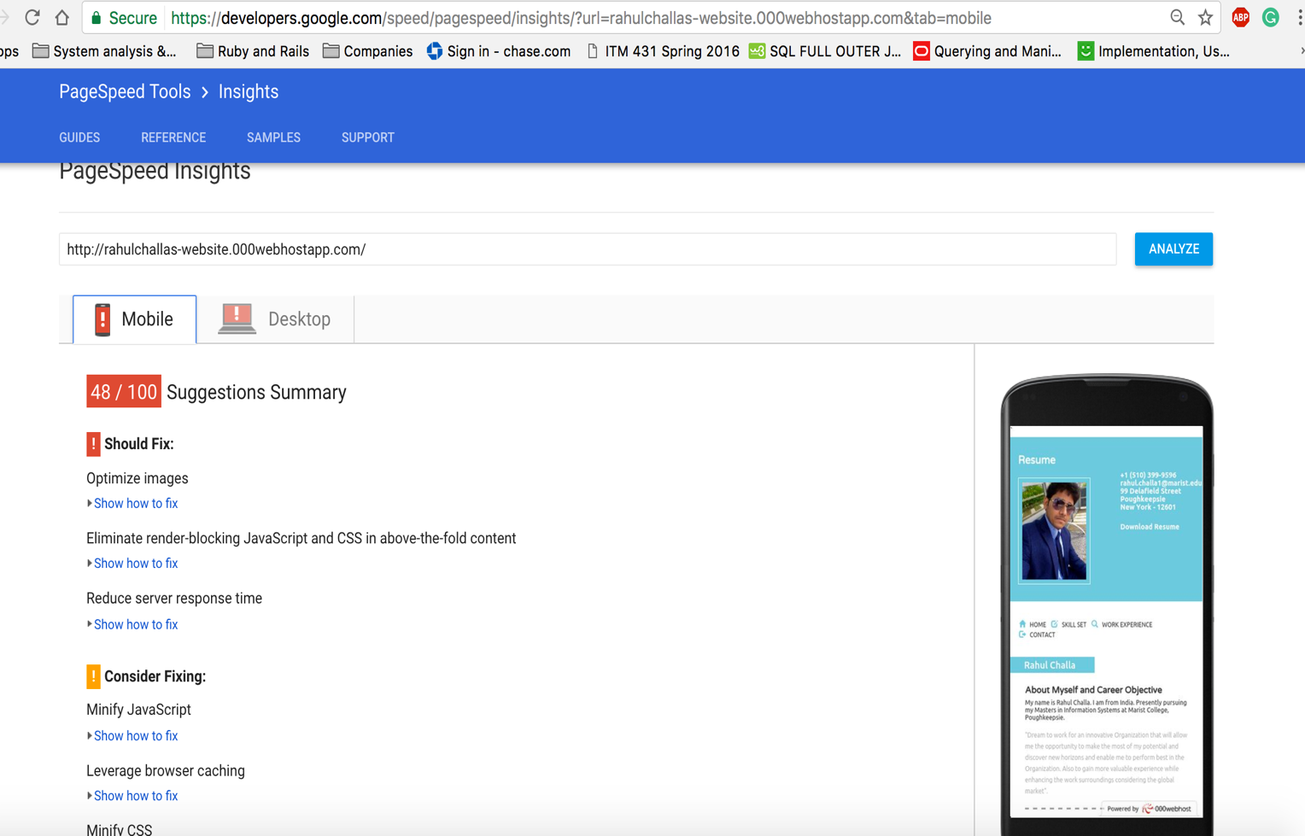

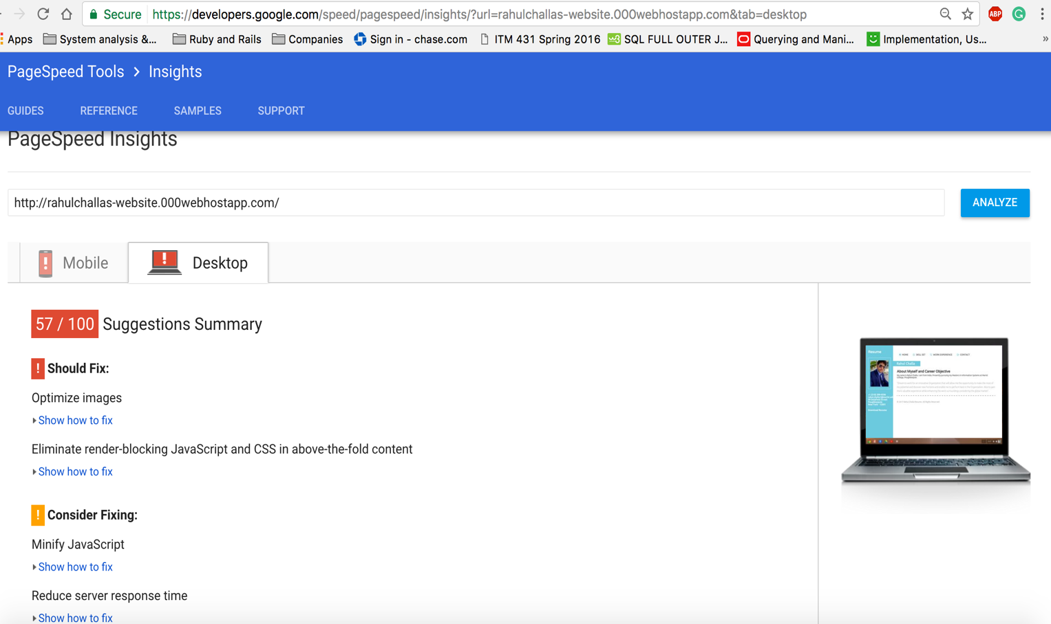

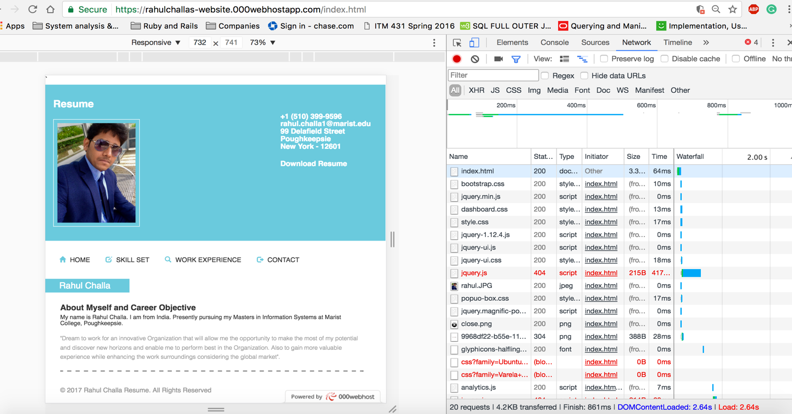

**🡪 Screenshots of PageSpeed Insights and website load times in the network tab after minifying:**

* I didn’t got much changes in the network tab for my website after minifying JQuery and CSS and JS and HTML files.
* The network work load has been decreased to 9ms (64ms to 55ms)

